Results:

After running the simulation, there were 50,000 species per evolution rate (41 different evolution rates ranging from 0.05 - 0.40), and 41 different simulations, ranging from 0.50 - 2.50.

Figure 1 | A graph of a master simulation with an environment change rate of one. Fitness, as how long a lineage can persist for in minutes, is represented as the Y axis and the color and size of the dots, and the evolution speed of a lineage on the X axis. 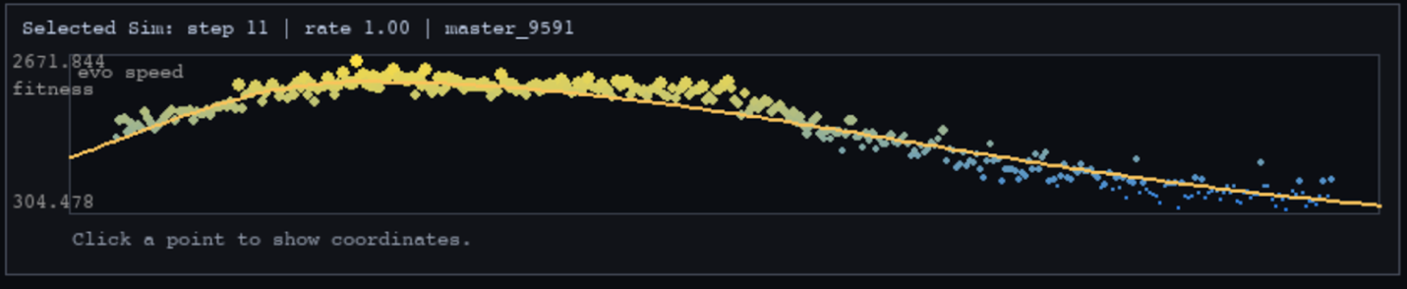

Through the results of the simulation, the bell curve had a peak fitness of 2672 minutes, with an evolution speed of 0.119. To the left and right of this apex, the fitness drops to a lower amount. The bell curve equation is:
y=2365.49*exp(-(|x-0.119|^2.3)/(2*0.0692848^2.3)) for x<=0.119; y=2365.49*exp(-(|x-0.119|^2.3)/(2*0.156128^2.3)) for x>0.119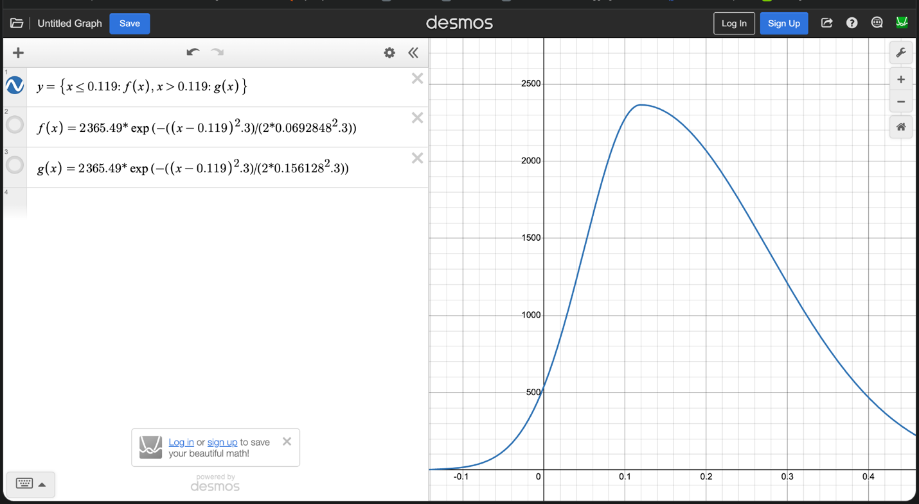
Figure 2 | This is an image of the bell curve of the bell curve seen in figure 1.

Inside of the equation of figure one, there is a total of 50118 species and datapoints, which is then grouped into 351 smaller groups that are presented as datapoints. The bell curve has a strong fit with an R value of 0.976, and a R² value of 0.952, and an RMSE of 156, meaning is deviates from the bell curve line of 156 minutes. Furthermore, this data is repeatable because it has a P value of 9.63e-233.

This show that for in terms of evolution speed, there is a peak evolution speed that will lead to the highest fitness, and going left and right of the apex the fitness decreases.

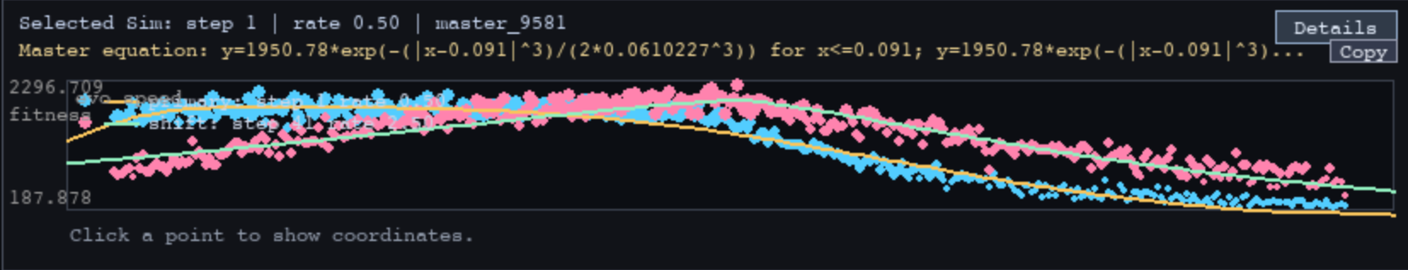 Figure 3 | This chart is an overlay of two different charts. The first chart being one with an environment change rate of 0.50, and the other one with an environmental change rate of 2.50. These two graphs are then overlaid on top of each other.

The bell curve equation is the following:

For Environment change rate of 2.50
y=2073.18*exp(-(|x-0.227|^1.3)/(2*0.138147^1.3)) for x<=0.227; y=2073.18*exp(-(|x-0.227|^1.3)/(2*0.0825389^1.3)) for x>0.227

For the environmental change rate of 0.50.
y=1950.78*exp(-(|x-0.091|^3)/(2*0.0610227^3)) for x<=0.091; y=1950.78*exp(-(|x-0.091|^3)/(2*0.164464^3)) for x>0.091

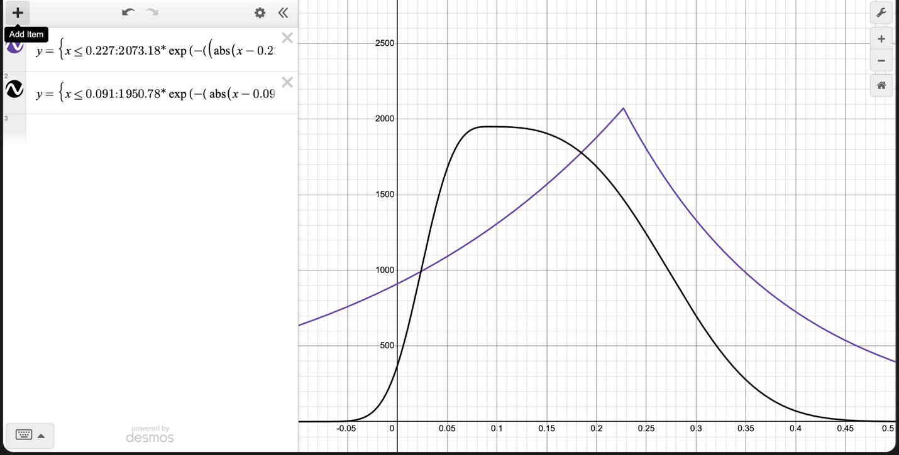
Figure 4 | Two charts representing the two graphs seen above overlaid on top of each other.

In figure three, the apex point for the lower environmental change rate (of 0.50) is with a 0.091 evolution rate and a fitness of 2197. For the higher environmental change rate (2.50), for the apex point the evolution rate is 0.227 with an fitness of 2297.
The environment with a lower environmental change rate favors lower evolution rate while higher environmental change rate favors higher evolution speed.

For the simulation with an environment change rate of 2.50, there are 50141 species and datapoints which are separated into 351 datapoints. The charts have a P value of 4.93e-159 and an R value of 0.935, and an R² value of 0.874, with an RMSE of 160.

For the simulation with an environment change rate of 0.50, there are 50118 species and datapoints which are separated into 351 datapoints. The charts have a P value of 1.21e-254 and an R value of 0.982, and an R² value of 0.963 with an RMSE of 129.

This shows the difference between environment change rate and how it affects the relationship between evolution speed and fitness.
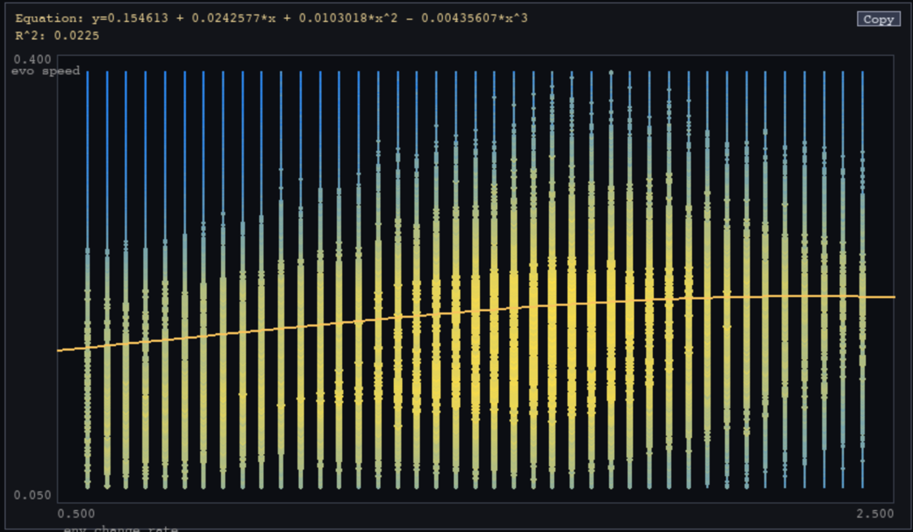
Figure 5 | The X axis shows the environmental change rate, and the Y axis shows the evolution speed, while the Z axis, represented by color and size, shows fitness. The Y axis and the Z axis combined create a graph similar to the one seen above. The places where the color is most yellow show where the highest fitness is for that environmental change rate, and as optimal fitness range goes up as the environmental change rate goes up.
The cubic function that represents this is: 0.155 + 0.0243x + 0.0103x^2 - 0.00425x^3. This function shows that the higher the environmental rate of change is, the higher the high evolution speed will have a high evolution speed.

This shows that as the environmental rate of change increases, the optimal evolution speed increases, and how fast this change showing the relationship in a more graph style.
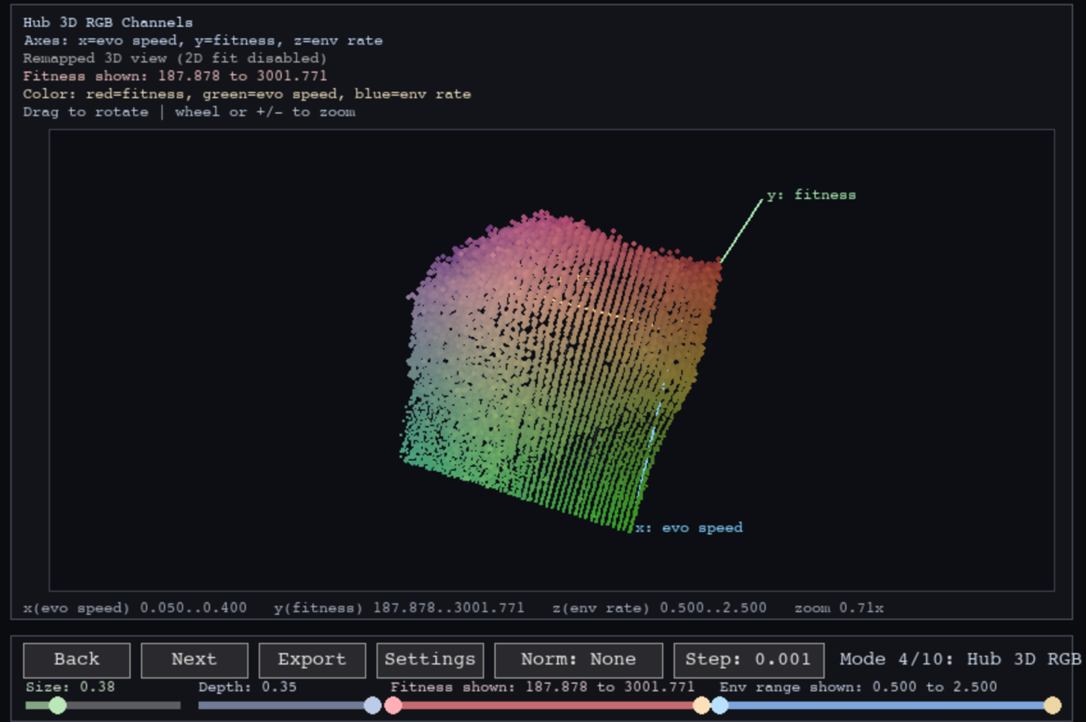
Figure 6 | This figure is another way to view all of the master simulations. In this 3d rendering, the X axis is the evolution speed, the Y axis is the fitness, and the Z axis is the environmental change rate. For the colors, red represents fitness, green for evolution speed, and blue for environment rate.
Inside of figure six, different things are noticeable. Firstly, as the environment rate of change increases, the apex fitness for each evolution speed will move more and more forward (higher evolution speed).
Secondly, at around 1.60 - 1.90 evolution change rate it allows the apex fitness to be higher when compared against other evolution change rates.

This shows in even greater detail how as evolution change rate changes, the relationship between environment speed and fitness gets affected.

